Ideation Phase
Define the Problem Statements

Date | 7 NOVEMBER 2025
Team ID | NM2025TMID06700
Project Name | Medical Inventory Management
Maximum Marks | 4 Marks

Customer Problem Statement Template:

The customer problem in the current medical inventory process arises from the lack of an efficient and centralized system to manage medical supplies, medicines, and equipment. Hospitals and healthcare centers often face challenges such as stock shortages, overstocking, and expired medicines due to manual tracking methods. The absence of real-time visibility into inventory levels leads to delays in treatment and increased operational costs.

Procurement processes are often slow and unorganized, resulting in inconsistent supply chain management. Additionally, data inaccuracies and lack of automated alerts make it difficult to maintain compliance and ensure patient safety. Customers need a streamlined, automated, and reliable solution that provides accurate stock monitoring, expiry tracking, and efficient supplier management within a single platform.

Problem and Solution:
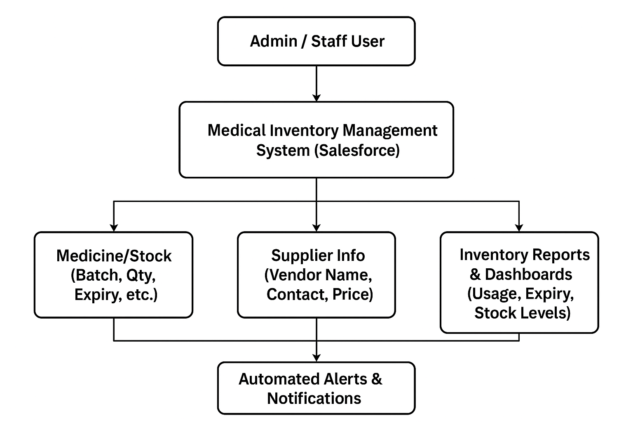
Example:

+---------------------------+
| Admin / Staff User |
+-------------+-------------+
|
v
+-----------------------------------------+
| Medical Inventory Management System |
| (Salesforce) |
+-----------------------------------------+
| | |
| | |
v v v
+----------------+ +----------------+ +----------------+
| Medicine/Stock | | Supplier Info | | Purchase Orders|
| (Batch, Qty, | | (Vendor Name, | | (Order ID, |
| Expiry, etc.) | | Contact, Price)| | Status, Date) |
+----------------+ +----------------+ +----------------+
| |
| v
| +-----------------------+
| | Inventory Reports & |
| | Dashboards (Usage, |
| | Expiry, Stock Levels) |
| +-----------------------+
|
v
+----------------------+
| Automated Alerts & |
| Notifications (Low |
| Stock / Expiry) |
+----------------------+

Problem Statement – PS1
Hospitals and healthcare centers face major challenges in efficiently managing their medical inventory due to manual tracking and lack of automation. The absence of a centralized system often leads to stock shortages, overstocking, and expired medicines, which directly impact patient care and operational efficiency. Additionally, data inaccuracy, delayed procurement, and poor visibility into stock levels make it difficult for staff to make timely decisions. There is a strong need for a digital solution that can streamline inventory tracking, automate alerts, and provide real-time visibility into medical supplies across departments.

Problem Statement – PS2
To overcome the challenges of manual inventory tracking and management, a Salesforce-based Medical Inventory Management System is proposed. This system will provide a centralized platform to record, monitor, and manage medical stock, suppliers, and purchase orders in real time. It will include features such as automated alerts for low stock and expiry, supplier management, and dynamic dashboards for data visualization. By automating repetitive tasks and ensuring data accuracy, the system aims to reduce wastage, enhance operational efficiency, and improve healthcare service delivery. The solution ensures that hospitals always have the right medical supplies available when needed, improving both cost control and patient safety.

